BIGTREETECH SKR V1.3

一．Introduce

BIGTREETECH SKR V1.3 motherboard is R&D by Shen Zhen Big Tree Technology CO.,LTD. .The BIGTREETECH SKR V1.3 motherboard not only with a high cost-effective but especially suitable for small and medium-sized 3D printers.

1.SKR motherboard features:

1) Using 32-bit main frequency 100MHz ARM level Cortex-M3 series LPC1768 main control chip, the performance has been greatly improved;

2) Equipped with highly modular and open source firmware Marlin2.0 and Smoothieware, it is convenient for users to DIY and secondary development, and can avoid worries of not mastering the core code;

3)Marlin2.0 uses powerful development tools, Visual Studio Code integrated development environment: support online debugging, more helpful for product development and performance optimization, using C language development, low development threshold.

4) PCB board wiring is rigorous and beautiful, and specialized in heat dissipation optimization treatment;

5) the use of dedicated power chip, support 12-24v power input;

6) it can accept 24V input and reduce the hotbed current to 1/4 at the same power, effectively solving the heating problem of hotbed MOS tube;

7) Support 2.8-inch and 3.5-inch color touch screens, support 2004 LCD and 12864 LCD.

8) The system supports simplified Chinese, English and other languages, and can switch by itself;

9)Upgrade and configure the firmware through SD card, which is simple, convenient and efficient.

10)The SPI working mode of the TMC2130 driver and the UART working mode driven by the TMC2208,, which eliminates complex wiring process and can be used by simple unplugging jumper cap;

11)Support Resume Printing While Power Off,Filament Break Detection,Automatic Shutdown After Printing and other functions.

12) High performance MOSFET tube, better heat dissipation effect;

13) The use of removable fuse makes the replacement process easier;

14) Reserved extended port SERVOS of PWM signal to support BL Touch;

15) Use the power selection design to separate the USB power supply from the switch power supply, effectively avoiding the situation that the USB port of the computer is burnt out due to short circuit;

16) The special function interface USES the row needle with conspicuous color, which greatly reduces the error rate of wiring.

2. SKR Motherboard Parameters:

Appearance size: 110*85mm

Mounting size: 102*76mm

Microprocessor: ARM cortex-M3 CPU

Input voltage: DC12V-DC24V 5A-15A

Motor driver: support TMC2208, TMC2130, ST820, LV8729, DRV8825,

A4988, can be independently external motor drive

Driver working mode support: TMC2130SPI, TMC2208UART

Motor drive interface: X, Y, Z, E0, E1, five (each has a reextendable interface),

Up to 256 subdivisions

Temperature sensor interface: TH0, TH1, TB, 3 channel 100K NTC (thermal resistance)

Display: 2.8 "TFT, 3.5" TFT, LCD2004, LCD12864

PC communication interface: square USB, easy to plug, communication baud rate of 115200

Expand the interface function support: Resume Printing While Power Off,Filament Break Detection,Automatic Shutdown After Printing, Automatic leveling, BL Touch

Support file format: g-code

Supported machine architecture: XYZ, Delta, Kossel, Ultimaker, Corexy

Recommended software: Cura, Simplify3D, pronterface, Repetier-host, Makerware

二．SKR motherboard electricity:

When the SKR motherboard is electricity , the red light D4 in the lower left corner will light up, indicating that the power supply is normal. The middle of the board

5V SEL is the power selection end;

1) when using USB to power the motherboard, short circuit cap should be used to connect +5V and USB legs;

2) when using 12v-24v power supply, short circuit cap shall be used to connect +5V and INT pins;

Note: can be connected [12v-24v power], [USB] at the same time , the printing process must be connected with a short circuit cap +5V

And INT.

三, SKR V1.3 Motherboard and Computer Connect

The SKR motherboard connects with the computer via the [USB] interface. After the driver is installed, the motherboard can be inserted into the computer to recognize the port for data transmission. Without the driver installed, it is easy for the computer to not recognize the USB port.

1. Smoothieware-usb-driver-v1.1 driver installation (Windows systems only)

The driver can be obtained from our open-source network;

<Https://www.dropbox.com/s/ighnj7oa2l0bm5g/smoothieware-usb-driver-v1.1.exe?dl=0>

2. After installing the driver, connect the computer and SKR motherboard with USB cable.

Open the “Device Manager” of the computer to view the COM number to which the “smoothieboard USB Serial” asynchronous communication port belongs.

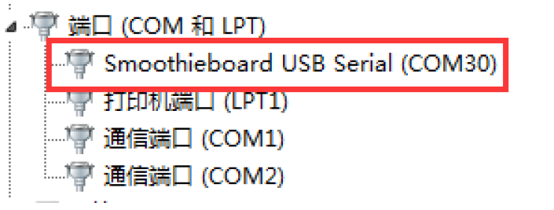

Note: When using smoothieware open-source firmware, since only Windows system drivers, the SKR board at this time can only be recognized by the Windows system port! ! !

3. If you are using Marlin2.0 firmware, follow the tutorial to install:

Tutorial: <https://www.dropbox.com/s/ppjfflhf3j5yzh2/MarlinV2.0%20SKRV1.1%20instruction.docx?dl=0>

Driver: [https://www.dropbox.com/s/a0k5idjmf4fn82f/lpc176x_usb_driver.inf?dl=0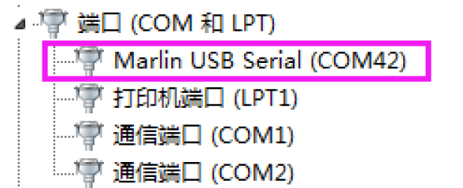](https://www.dropbox.com/s/a0k5idjmf4fn82f/lpc176x_usb_driver.inf?dl=0)

四, SKR V1.3 Motherboard and Interface Instruction

1. SKR Motherboard Size Diagram

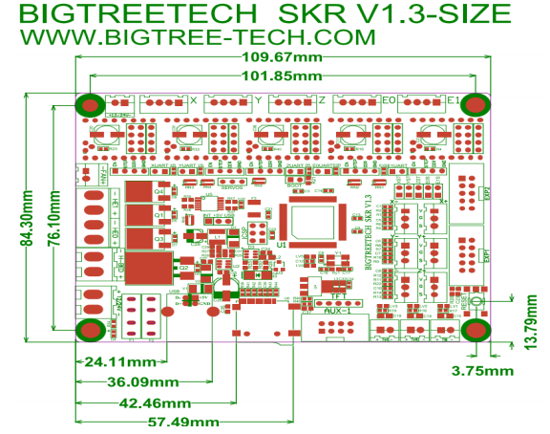

2.SKR Motherboard Wiring Diagram

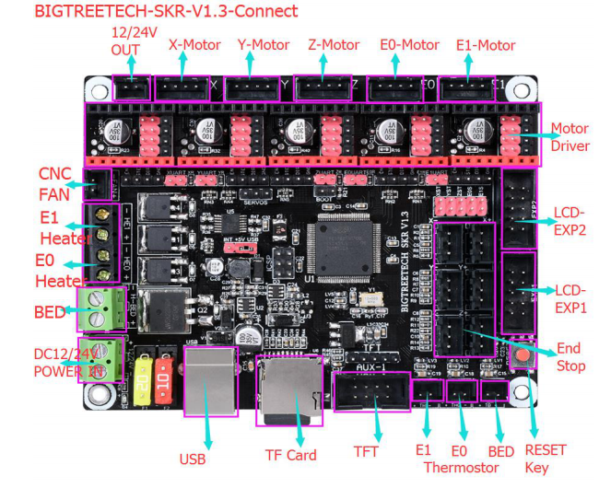

3.Drive Mode and Selection Method:

① Normal STEP/DIR mode:

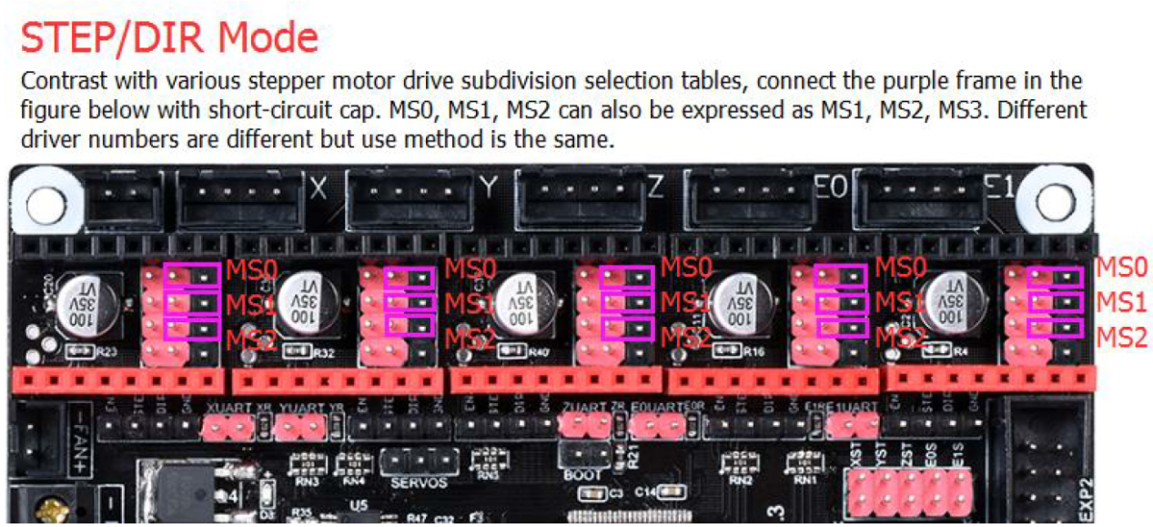

②TMC2208 UART Mode:

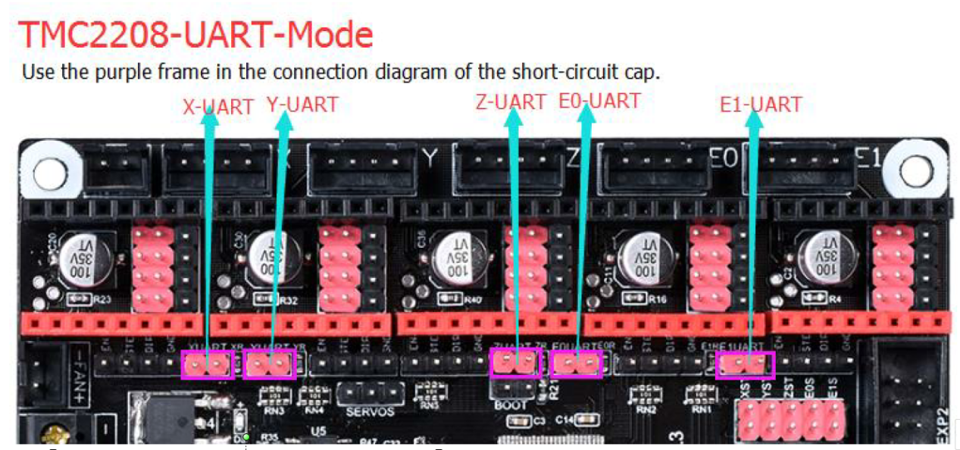

③TMC2130 SPI mode: 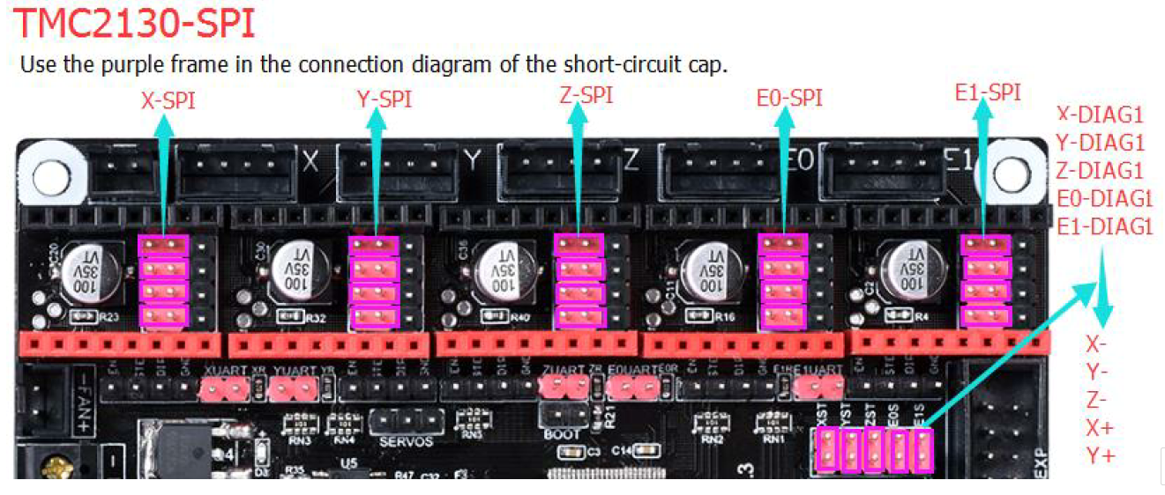

1. The firmware description of SKR motherboard

The factory motherboard is installed equipped with firmware for testing (model I3), which can be used directly or changed according to your own needs

1.The Firmware Acquisition Method of SKR Motherboard.

Obtain by Ask customer service or technical personnel ;

Download at our Company Open source website:

<https://github.com/bigtreetech>

1. Smoothieware Firmware update method
2. Choose the file suitable for your model in the downloaded firmware package to copy to SD Card Root directory，Include:

①Firmware: **firmware.bin** (Choose according to your model )

②Configuration file **config.txt(**change your configuration by youself according your own needs**)**

Detailed functional options in the configuration file can be referred to the Open source Website:**http://smoothieware.org/configuration-options**

Note: File name cannot be changed, firmware. bin must be lowercase!

2) Insert SD card into the main board SD card slot, re-energize or press the reset key, wait for about 10S.

After that, the update can be completed.

1. Marlin 2.0 firmware update method
2. After downloading our company's open source Marlin 2.0 firmware,open the project in Visual Studio Code,building it, then find the firmware. bin file, copy it to the SD card, and reset the motherboard.

For detailed steps, please refer to the tutorial:

https://www.dropbox.com/s/ppjfflhf3j5yzh2/MarlinV2.0%20SKRV1.1%20instruction.docx?dl=0

1. Notes:

1. The 5V SEL of the motherboard must be connected with INT and + 5V pins before printing (that means there must using the 12V-24V power supply to the motherboard for printing.

2. The power of the hot bed connected to the motherboard must be less than or equal to 144W (i.e. the resistance value of the hot bed is above 1Ω). If using high-power hot bed , it must connected to the power expansion plate of the hot bed )

3.Firmware file names in SD Card cannot be changed (including both upper and lower case letters);

4.The wiring process and the plug-in drive process must be carried out under the premise of power off. The power on can be started after checking the correct connection of the line and the correct insertion of the drive, so as to prevent the wrong connection of the main board and drive from being burnt down and causing unnecessary losses.

5.If you want to replace the configuration file, please backup the factory configuration file to record the pin number of each part of the chip, and then make changes to the new configuration file!

FAQ (Frequently Asked Questions)

Q: The computer does not recognize the SKR motherboard?

A: Check if the smoothieware-usb-driver-v1.1 driver is installed, you can downloading and installing it through the original URL, connect the power selection port jumper cap to USB and +5V.  
and connect the USB cable to the computer and the SKR motherboard.

Q: After changing the configuration file, insert the motherboard, the firmware failed to update successfully?

A: Check if the format of the firmware.bin file in the SD card is correct, also the file name should be lowercase

If you encounter other problems while using, please contact us, we will answer you scrupulous; if you have any good comments or suggestions for our products, pls feel free to inform us, we will carefully consider your comments or suggestions, thank you for choosing BIGTREETECH products, thank you!